City Scape Faletti’s Service Apartment Development Progress

Introduction:
The Real Estate landscape is constantly evolving, and transparency in construction progress plays a vital role in building trust with investors and buyers. City Scape Faletti’s Service Apartment Development Progress reflects our commitment to quality construction, modern design, and timely execution. This project has been carefully planned to meet international living standards while offering long-term value to investors and residents alike.

At City Scape Developers, we believe that every stage of construction tells a story— one of engineering precision, material excellence, and thoughtful planning. Our service apartment project near Faletti’s is progressing steadily, with concrete pouring work successfully completed and ground floor development currently underway. Each phase is being executed under strict supervision to ensure durability, safety, and architectural excellence.
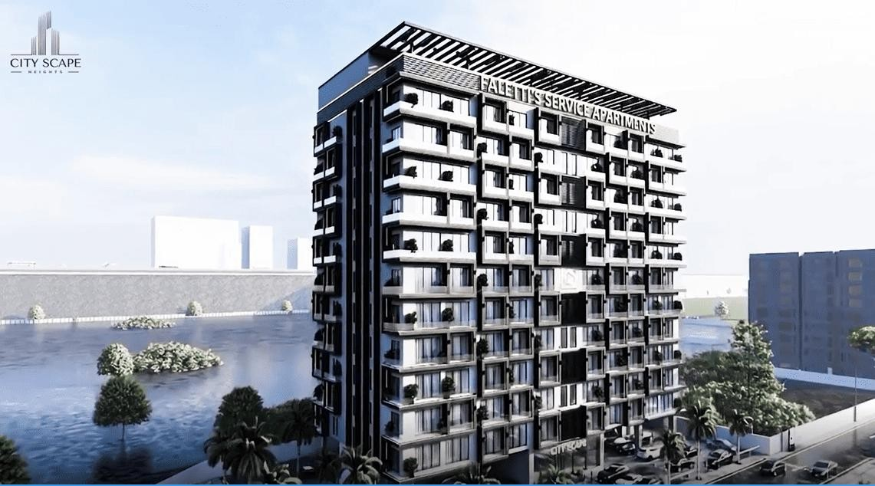

This detailed construction update provides a transparent overview of our development journey so far, highlighting completed milestones, current on-site activities, construction materials, safety practices, and upcoming phases. Whether you are an investor, a future resident, or someone tracking premium real estate developments, this blog offers a comprehensive insight into City Scape Faletti’s Service Apartment Development Progress.

Overview of Our Real Estate Development Project
Project Location and Accessibility

City Scape Faletti’s Service Apartment Development Progress

Introduction:
The real estate landscape is constantly evolving, and transparency in construction progress plays a vital role in building trust with investors and buyers. City Scape Faletti’s Service Apartment Development Progress reflects our commitment to quality construction, modern design, and timely execution. This project has been carefully planned to meet international living standards while offering long-term value to investors and residents alike.

At City Scape Developers, we believe that every stage of construction tells a story— one of engineering precision, material excellence, and thoughtful planning. Our service apartment project near Faletti’s is progressing steadily, with concrete pouring work successfully completed and ground floor development currently underway. Each phase is being executed under strict supervision to ensure durability, safety, and architectural excellence.

This detailed construction update provides a transparent overview of our development journey so far, highlighting completed milestones, current on-site activities, construction materials, safety practices, and upcoming phases. Whether you are an investor, a future resident, or someone tracking premium real estate developments, this blog offers a comprehensive insight into City Scape Faletti’s Service Apartment Development Progress.

Overview of Our Real Estate Development Project

Project Location and Accessibility
City Scape Faletti’s Service Apartment project is strategically located in a prime area near Faletti’s, offering excellent connectivity to major roads, commercial hubs, and lifestyle destinations. The location has been carefully selected to ensure ease of access, high rental demand, and long-term appreciation.


Residents and investors benefit from:

- Close proximity to business districts
- Easy access to major road networks
- Nearby hotels, restaurants, and recreational facilities

This prime location makes the project ideal for serviced living, short-term stays, and long-term investment opportunities.

Purpose of the Building Development
The primary purpose of this project is to develop premium service apartments that combine luxury, comfort, and functionality. Designed to cater to business travelers, tourists, and long-stay residents, these service apartments will offer hotel-like amenities with the privacy of a residential setup.

From an investment perspective, the project targets:

- Consistent rental income
- Strong occupancy rates
- Capital appreciation over time

Design Philosophy and Planning Vision
Our design philosophy focuses on modern architecture, efficient space utilization, and structural longevity. The planning stage involved detailed architectural and engineering coordination to ensure:

- Optimal natural light and ventilation
- Smart layouts for service apartment living
- Structural strength for long-term use

Every design decision aligns with our vision of delivering a high-quality real estate development that stands the test of time.

Importance of Strong Foundation in Building Construction

Why Foundation Quality Matters in Real Estate Projects
A strong foundation is the backbone of any successful building. In service apartment developments, where safety and durability are paramount, foundation quality directly impacts structural stability and long-term performance.

- A well-executed foundation:
- Prevents structural settlement
- Enhances building lifespan
- Ensures occupant safety

At City Scape Faletti’s Service Apartment project, foundation work was treated as a critical milestone, executed with precision and adherence to engineering standards.

Materials and Engineering Standards Used
The foundation construction involved high-grade cement, reinforced steel, and properly graded aggregates. Structural drawings approved by qualified engineers guided the entire process, ensuring load distribution and seismic resistance.

Quality checks were carried out at every step to meet national and international construction standards, reinforcing our commitment to excellence.

Concrete Pouring Work Successfully Completed

What Is Concrete Pouring in Building Construction?
Concrete pouring is one of the most crucial phases in any building project. It involves placing concrete into formwork to create structural elements such as foundations, columns, and slabs. The strength of a building heavily depends on how well this process is executed.

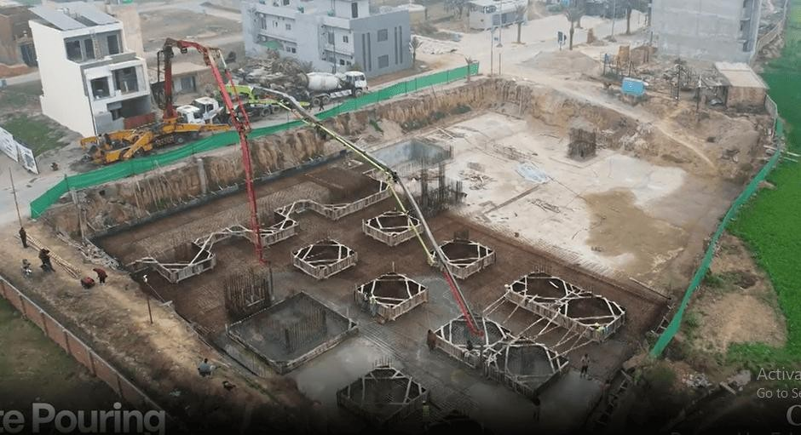

For City Scape Faletti’s Service Apartment Development Progress, concrete pouring marked a significant achievement in moving from groundwork to vertical construction.

Concrete Pouring Process Used in Our Project

The concrete pouring process was carried out in a systematic and controlled manner:

- Formwork was installed with precision to maintain alignment
- Steel reinforcement was inspected and approved
- Concrete was poured using proper techniques to avoid air gaps
- This method ensured uniform strength and structural integrity.

Quality Control During Concrete Pouring
Strict quality control measures were implemented throughout the concrete pouring stage. On-site engineers supervised the process, while material testing ensured consistency and strength.

Key quality practices included:

- Slump testing
- Controlled curing process
- Continuous monitoring of mix ratios

Timeline and Completion of Concrete Pouring Work
The concrete pouring work was completed within the planned timeline, reflecting effective project management and coordination. Completing this phase on schedule allowed us to seamlessly transition into ground floor development without delays.

This milestone represents a solid foundation—both literally and figuratively—for the future of the project.

Ground Floor Development Work Currently in Progress

Scope of Ground Floor Construction Work
With the foundation and concrete structure completed, ground floor development is now actively underway. This phase includes the construction of columns, beams, and walls that define the building’s base layout.

The ground floor forms the structural and functional framework of the service apartments, making this stage particularly important.

Brickwork and Structural Framing Details
High-quality bricks and masonry materials are being used to ensure strength and thermal insulation. Structural framing is executed as per approved drawings to maintain load balance and architectural accuracy.

Precision during this phase ensures seamless progression to upper floors in later stages.

Electrical and Plumbing Planning at Ground Floor Stage
Electrical conduits and plumbing lines are being planned and embedded during ground floor development. Early integration of utilities prevents future structural modifications and enhances overall efficiency.

This forward-thinking approach supports long-term maintenance and functionality.

On-Site Progress and Daily Supervision
Daily supervision by qualified engineers ensures construction accuracy and safety. Contractors and labor teams work under strict guidelines to maintain quality standards and timelines.

This hands-on supervision is a key factor in the smooth progress of City Scape Faletti’s Service Apartment Development Progress.

Construction Materials Used in Our Building Project

Cement, Steel, and Aggregates
Only premium-grade cement and reinforced steel are used in this project. Aggregates are carefully selected to achieve optimal strength and durability in concrete structures.

Brickwork and Masonry Materials
Brickwork materials are chosen based on strength, insulation, and longevity. These materials contribute to structural stability and energy efficiency.

Commitment to High-Quality Construction Materials
We believe that quality materials are a long-term investment. By prioritizing superior construction inputs, we ensure lasting value for buyers and investors.

Safety Measures Followed During Construction Work

Worker Safety and Equipment
Worker safety is a top priority. Protective gear such as helmets, gloves, and safety boots are mandatory on-site.

Site Management and Risk Control
Regular safety inspections and organized site management reduce risks and maintain a clean working environment. These measures ensure uninterrupted progress and workforce well-being.

Timeline and Next Phases of Building Development

Upcoming Construction Milestones

Following ground floor completion, upcoming phases include:

- First floor construction

- Structural framework for upper levels
- Roofing and slab work

Expected Completion Schedule
Each phase follows a structured timeline to ensure smooth progress and timely delivery.

Quality Checks at Each Stage
Inspections and approvals are conducted at every stage to maintain construction integrity and compliance.

Why This Real Estate Project Is a Smart Investment

Location Advantage
The project’s prime location near Faletti’s ensures high demand for service apartments, making it an attractive investment option.

Construction Quality and Transparency
Regular construction updates and transparent communication build investor confidence and trust.

Long-Term Value for Buyers and Investors
With strong construction, strategic location, and premium design, City Scape Faletti’s Service Apartment Development Progress represents a promising long- term investment.

Our Commitment to Transparency in Construction Updates

Regular Project Progress Reports
We regularly share updates through blogs, photos, and on-site visits to keep stakeholders informed.

Open Communication With Clients and Investors

Our team maintains open communication channels, ensuring clarity and trust throughout the development journey.

How Buyers and Investors Can Get Involved

Booking and Inquiry Process
Early booking options provide investors with competitive advantages and flexible plans.

Site Visit and Consultation
Interested buyers and investors are welcome to schedule site visits and consultations for firsthand insight.

Frequently Asked Questions (FAQ)

Is the foundation work completed?
Yes, the concrete pouring and foundation work have been successfully completed.

What stage is the project currently in?
Ground floor development is actively in progress.

When will the next phase begin?
First floor construction will begin after ground floor completion.

What materials are being used?
Premium-grade cement, steel, and masonry materials are used.

Is this a good time to invest?
Yes, early-stage investment offers strong growth potential.

Conclusion
The City Scape Faletti’s Service Apartment Development Progress reflects our dedication to quality, transparency, and timely execution. With concrete pouring completed and ground floor development underway, the project is steadily transforming from vision to reality.

Every phase is being executed with precision, ensuring structural integrity, modern design, and long-term value. We invite investors and buyers to follow our journey,

visit the site, and become part of a premium real estate development designed for the future.

